
J&J hosted 4Q 2025 IR call; Bleximenib R/R AML data readout and US submission now planned for 2026
Company: J&J  Drug: Bleximenib (menin-MLLi) | Date: Jan 21, 2026  Source(s): Webcast, Press Release, Presentation, Other Financial Disclosures, Earnings Infographic
What happened:
- J&J hosted its’ 4Q 2025 earnings call and highlighted that data readout from Ph 1/2 cAMeLot-1 (R/R KMT2Ar and NPM1m AML, bleximenib, N=400) study and subsequent US submission are now expected in 2026 (new guidance)

Approval timelines:
 | US | EU
R/R KMT2Ar and NPM1m AML  (cAMeLoT-1; bleximenib) | 1Q 2027  (Company’s guidance on data readout in 2026, possibly at ASCO/EHA 2026, with Ci projecting potential submission by end of 2Q or early 3Q 2026; updated timelines, previously 4Q 2026) | NA  (Company did not disclose submission plan; Additionally, the EMA may require a randomized trial; no changes to the timelines)
1L KMT2Ar and NPM1m unfit AML  (cAMeLot-2; bleximenib + Ven + Aza) | 3Q 2028  (Company can potentially leverage CR for AA in the US (aggressive scenario). A data readout could occur as early as 4Q 2027 (analogues timelines) leading to potential US submission in 1Q 2028; no changes to the timelines) | 3Q 2030  (It is unlikely that J&J will receive approval with CR in the EU and will need OS data for submission. Potential EU submission may happen in 3Q 2029, based on Jun 2029 PCD; no changes to the timelines)
1L KMT2Ar and NPM1m fit AML  (HOVON181AML; bleximenib + 7+3) | 1Q 2031  (Based on Jun 2030 PCD, CI estimates filing by end of 2Q 2030; no changes to the timelines) | 1Q 2031  (Based on Jun 2030 PCD, CI estimates filing by end of 2Q 2030; no changes to the timelines)

Impact (CI PoV): LOW
- Despite J&J’s confirmation of a bleximenib submission in R/R KMT2Ar and NPM1m AML for the first time, the near-term impact on Ven is expected to be modest, primarily limited to erosion of the off-label Ven + Aza use
- At the same time, bleximenib’s delayed market entry, despite J&J’s strong commercial capabilities, raises the bar for differentiation vs. already established menin inhibitors, Revuforj and Komzifti, to secure meaningful uptake in this setting

Why it matters (CI Insights in blue italics):
- This is the first company guidance on plans to submit bleximenib monotherapy in R/R AML in the US in 2026 (new guidance)
- Bleximenib will be the third potential menin inhibitor to enter R/R AML space, following Revuforj and Komzifti, with likely broad label, including both KMT2Ar and NPM1m population
  - J&J to date has only disclosed pooled bleximenib (KMT2Ar and NPM1m), across three dose levels, highlighting the 100 mg emerged as the most promising and elected as RP2D
  - Efficacy appears competitive in the NPM1m AML, with bleximenib demonstrating ORR:47.6% (n=21), numerically comparable to Revuforj (46.9%, n=64) and higher than Komzifti’s (33%, n=92), albeit in a smaller evaluable population
  - Safety may represent bleximenib’s key differentiator, with no signs of observed QTcP and lower rates of DS Gr≥3 AEs vs in-class-competitors (7% vs. 13% (NPM1m) and 15% (KMT2Ar) for Revuforj and 15% (NPM1m) and 25% (KMT2Ar) for Komzifti
  - Bleximenib’s BID dosing (100 mg) mirrors Revuforj’s regimen (163 mg BID), possibly enabling J&J to prioritize sustained target inhibition and safety management, counterbalancing Komzifti’s QD convenience advantage
- An additional critical factor in J&J’s substantially deeper and more established hematology footprint vs. Syndax and Kura, which could support more efficient trail execution in R/R AML, as well as in 1L AML, along with stronger real-world adoption through superior medical engagement, and commercial capabilities

Tell me more:
Financial Highlights:
Global | USD ($)
4Q 2024 sales | 22.5 B
4Q 2025 sales | 24.6 B
YoY change | +9.1%
FY 2024 revenue | 88.8 B
FY 2025 revenue | 94.2 B
YoY change | +6.0%

Data Tables
- Data summary from ASH 2023 and ASH 2024
Trial | Ph 1/2 cAMeLot-1 study
Dosing | Bleximenib (45 mg BID) | Bleximenib (90/100 mg BID) RP2D | Bleximenib (150 mg BID)
Data Ref. | ASH 2023, ASH 2024
Population (LOT) | R/R KMT2Ar or NPM1m AML, ALL
Efficacy (n) | 11 | 21 | 20
mFU (months) | 6.5
ORR (%) | 36.4 | 47.6 | 55.0
CR (%) | 18.2 [CRh] | 38.1 [CRh] | 40.0 [CRh]
Safety (n) | 146
Most common Gr≥3 TRAEs (%) | Thrombocytopenia (31) neutropenia (25), DS (7)

Relevant Slides

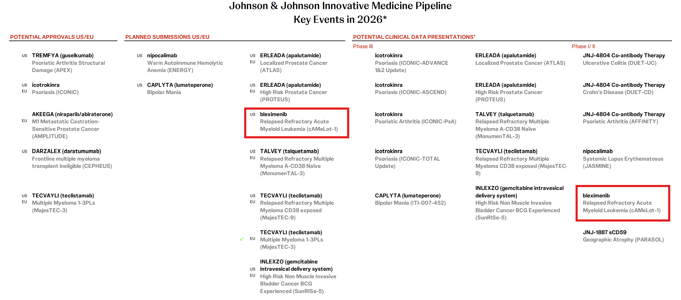

For questions, please reach out to:
International / Affiliates: Harjit Bajwa
US: Richa Sharma

Invite your colleagues to CI Edge | Manage Email Preferences | Unsubscribe

This document/email contains competitive intelligence collected via an approved competitive intelligence supplier working on behalf of AbbVie. We collect competitive intelligence consistent with industry standards and AbbVie policy. Not for field distribution. Please reach out to APEX/IMABI, Legal, or OEC teams with any questions.

